**AWS - EC2 instance creation**

[Santosh.thiruvanagiri@gmail.com](mailto:Santosh.thiruvanagiri@gmail.com)

$ONE

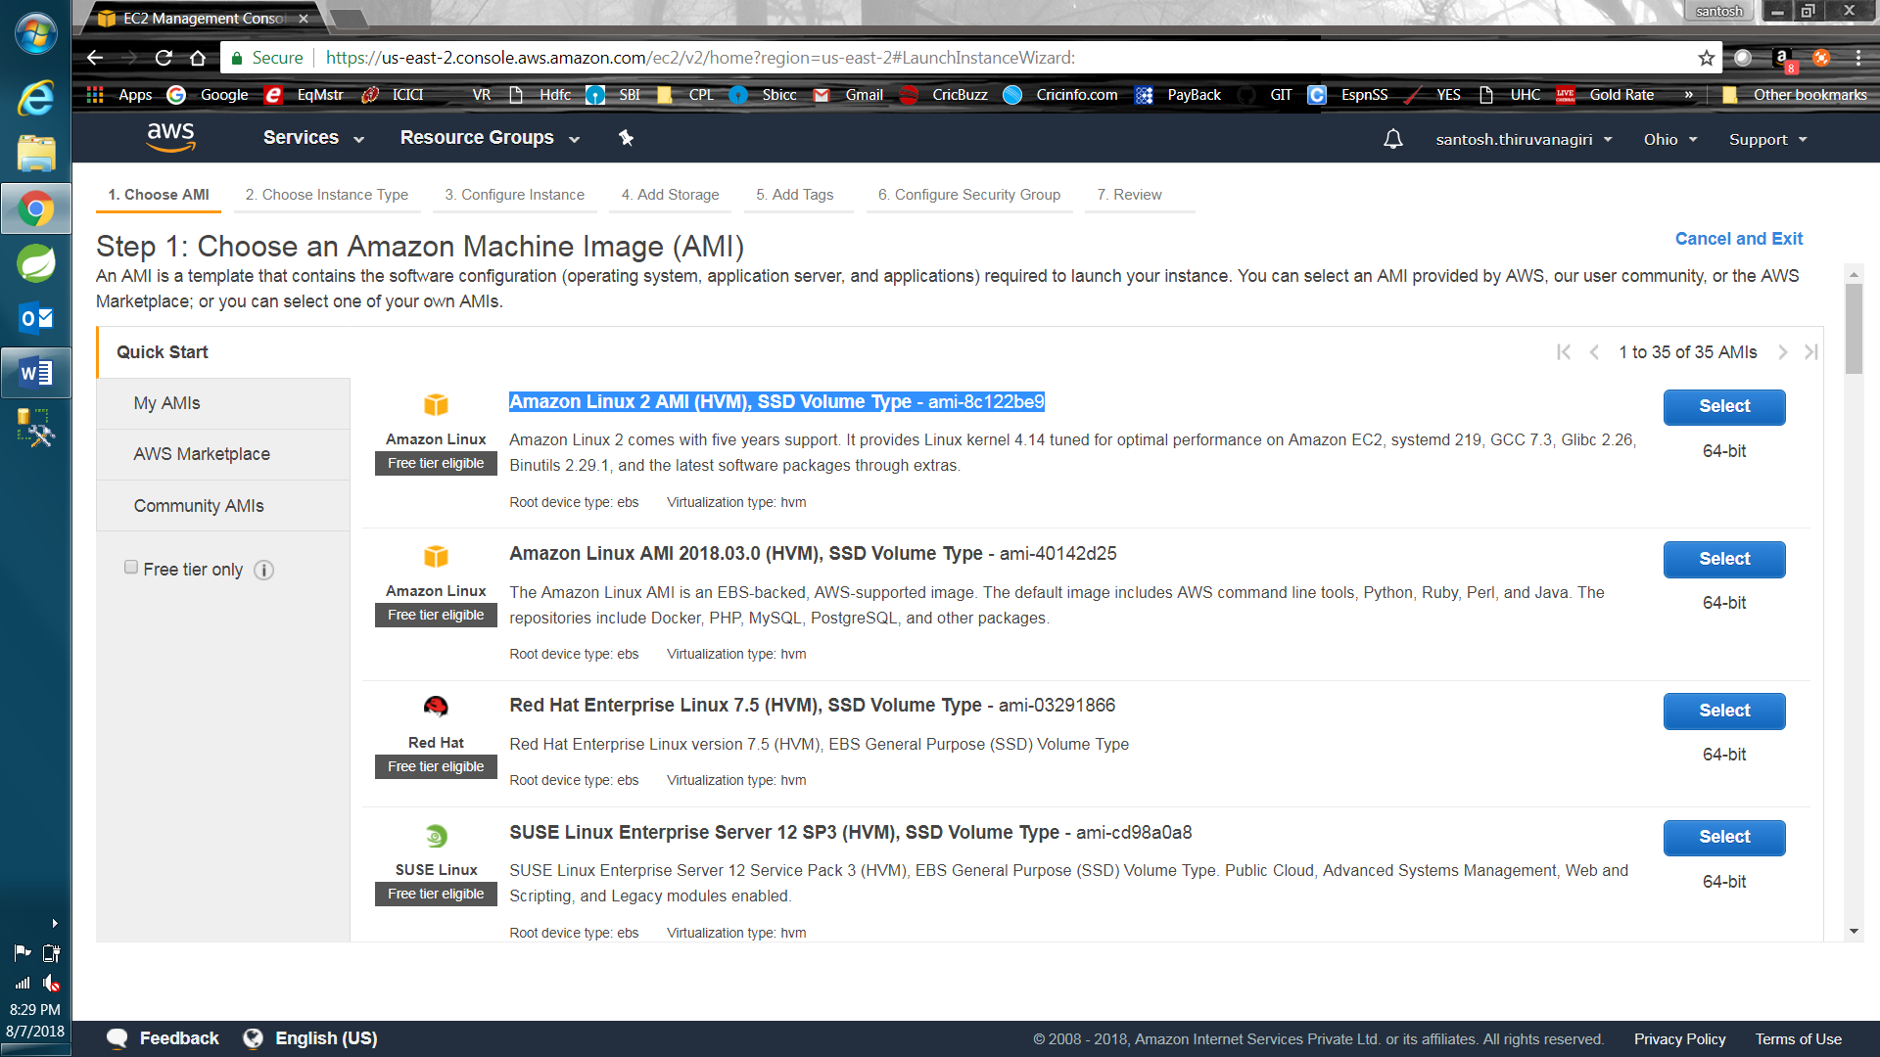

NEXT 🡪 NEXT

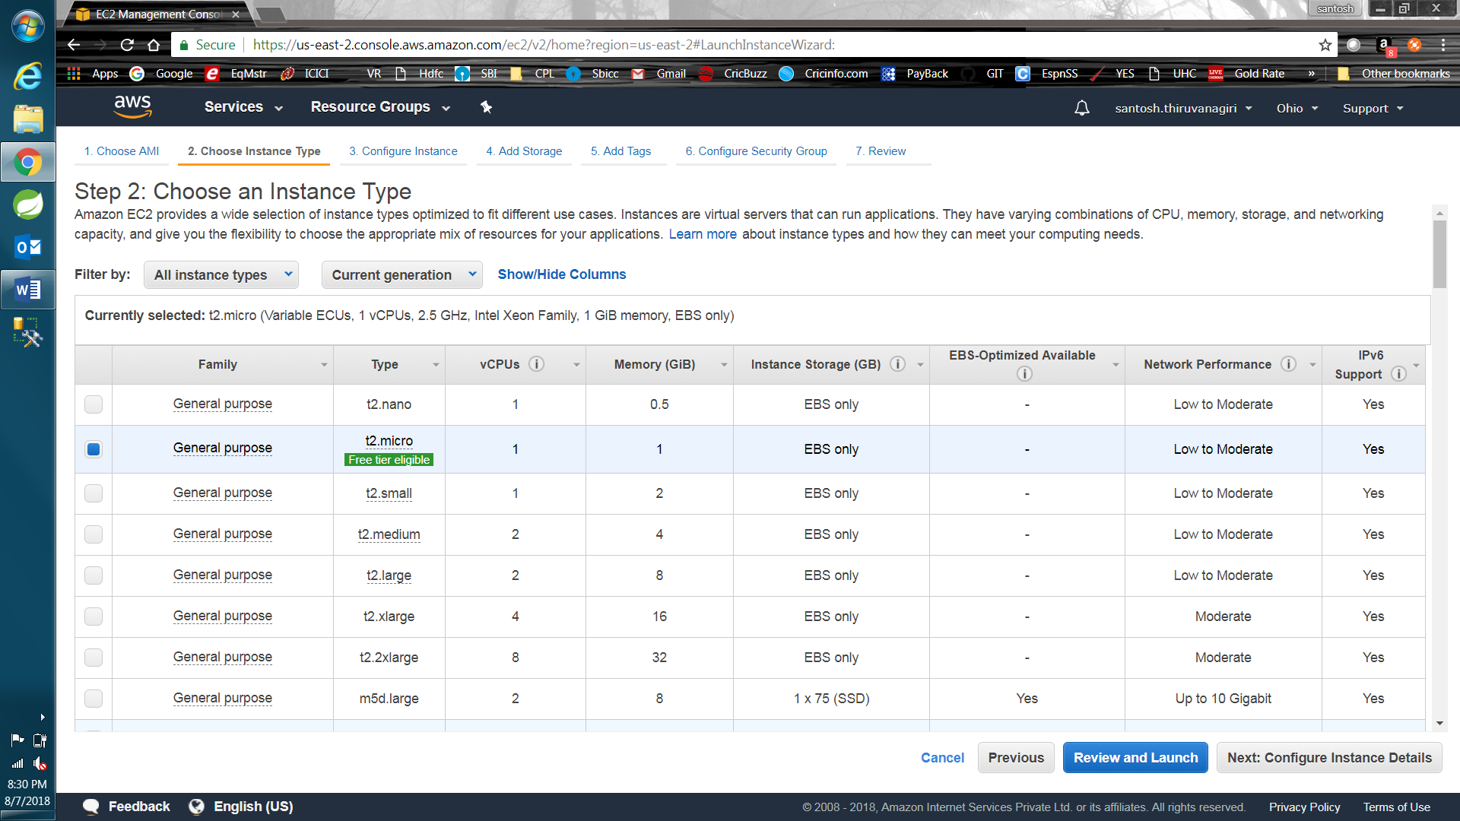

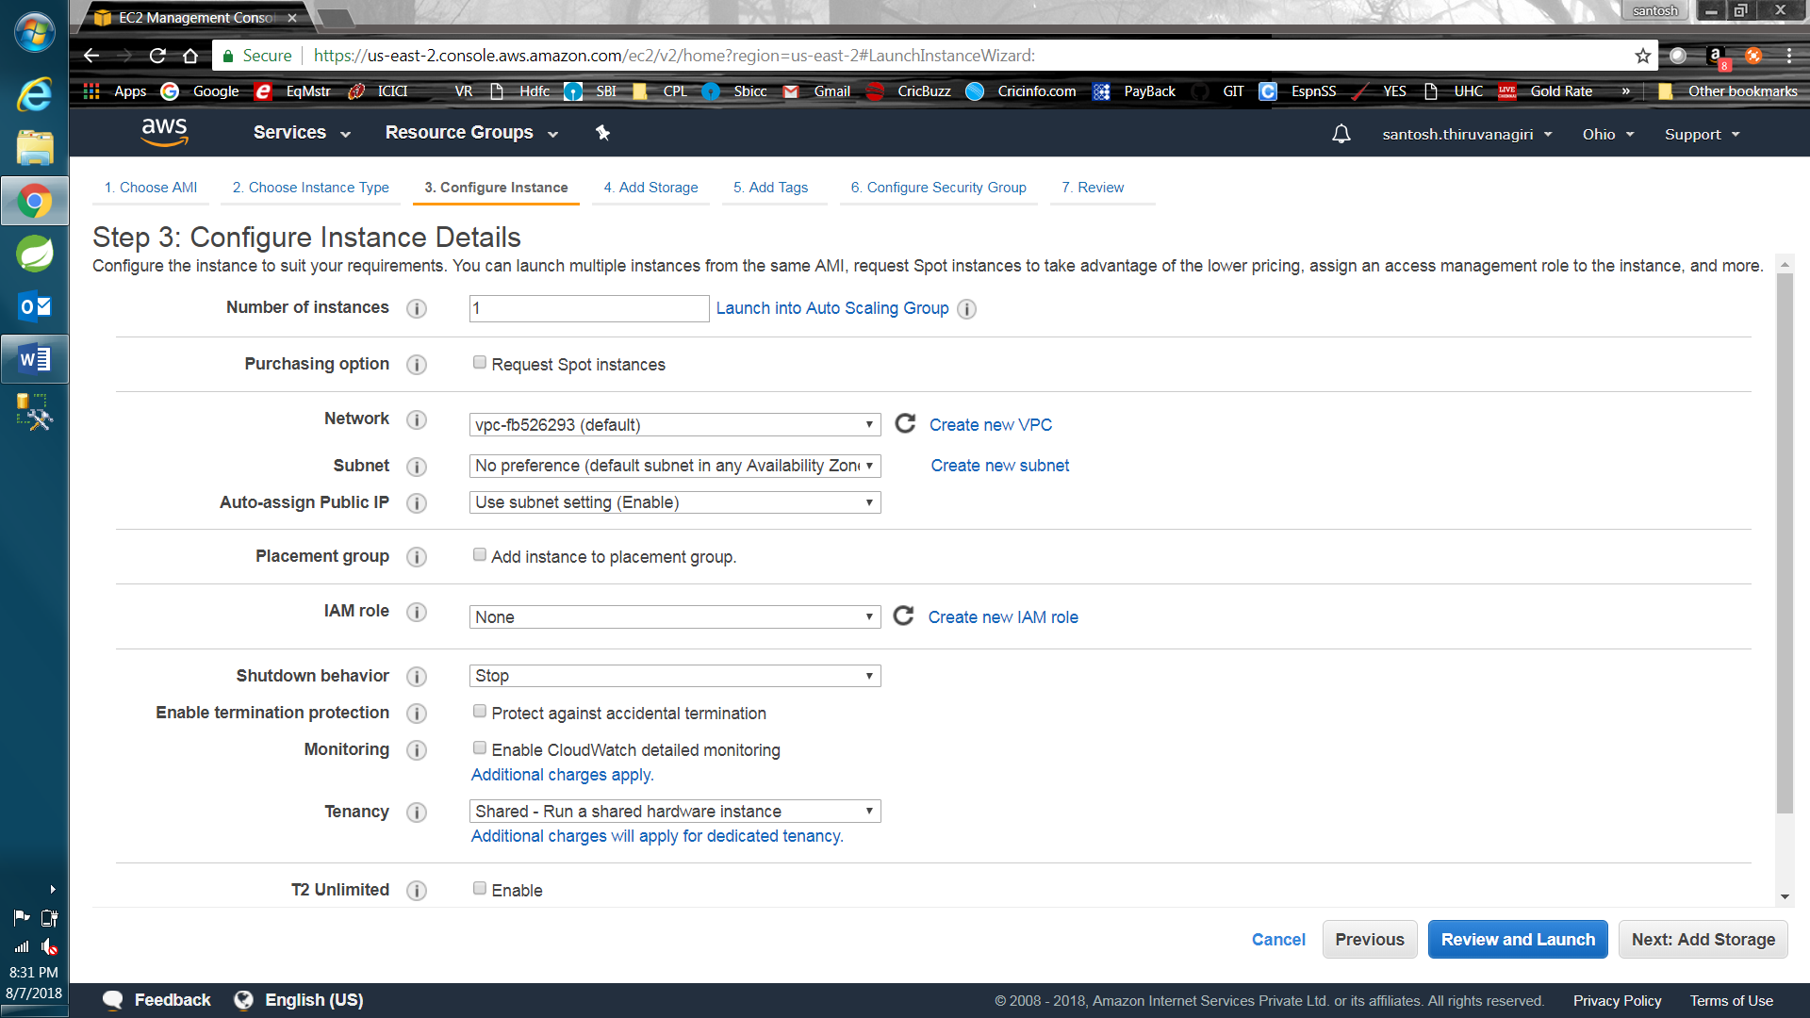

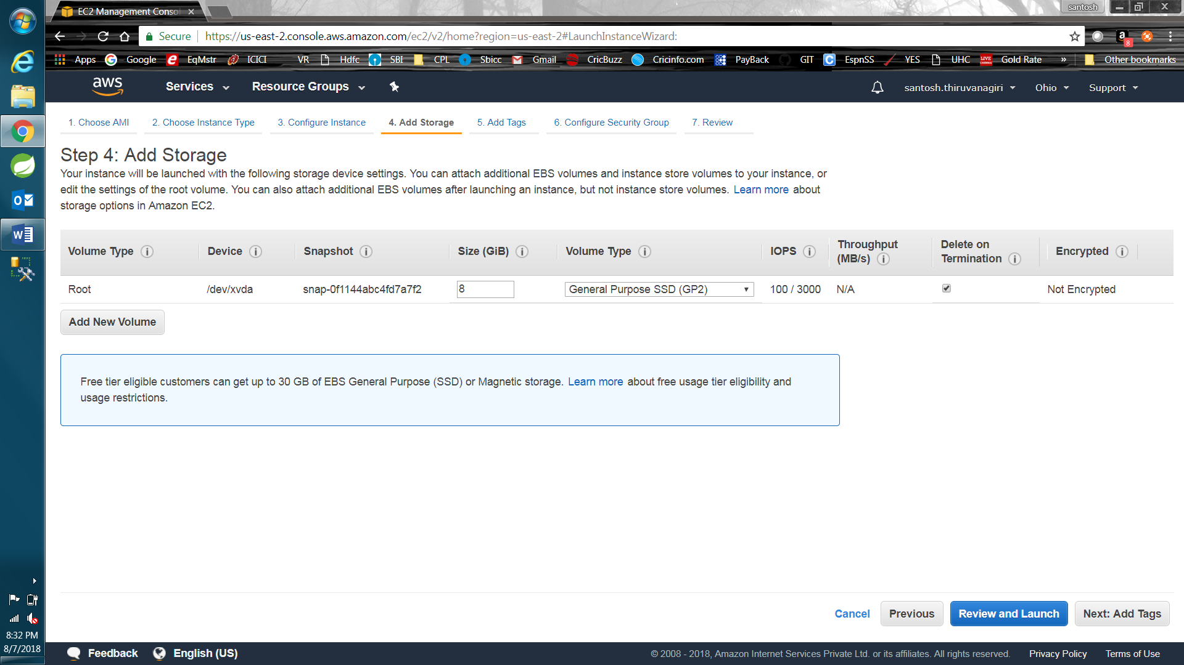

No tags needed here. Optional.

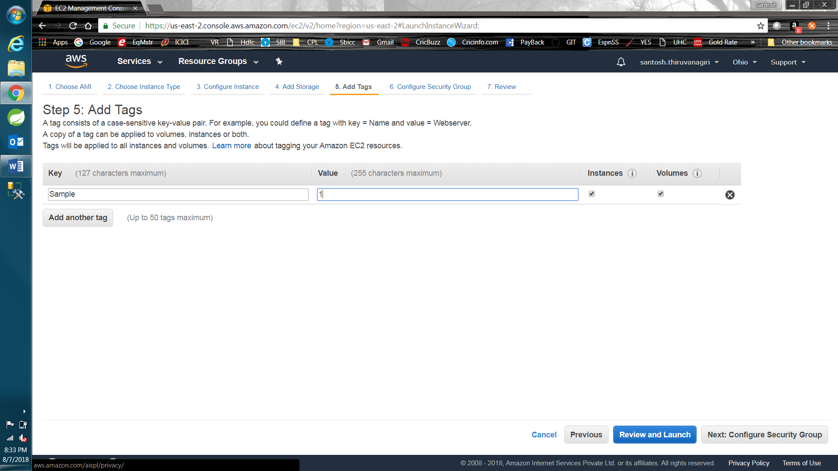

Here, We can configure many HTTP type ports. These ports will be exposed to outer world. So, later point of time, we need to map this public port to the port which we define inside for running docker container.

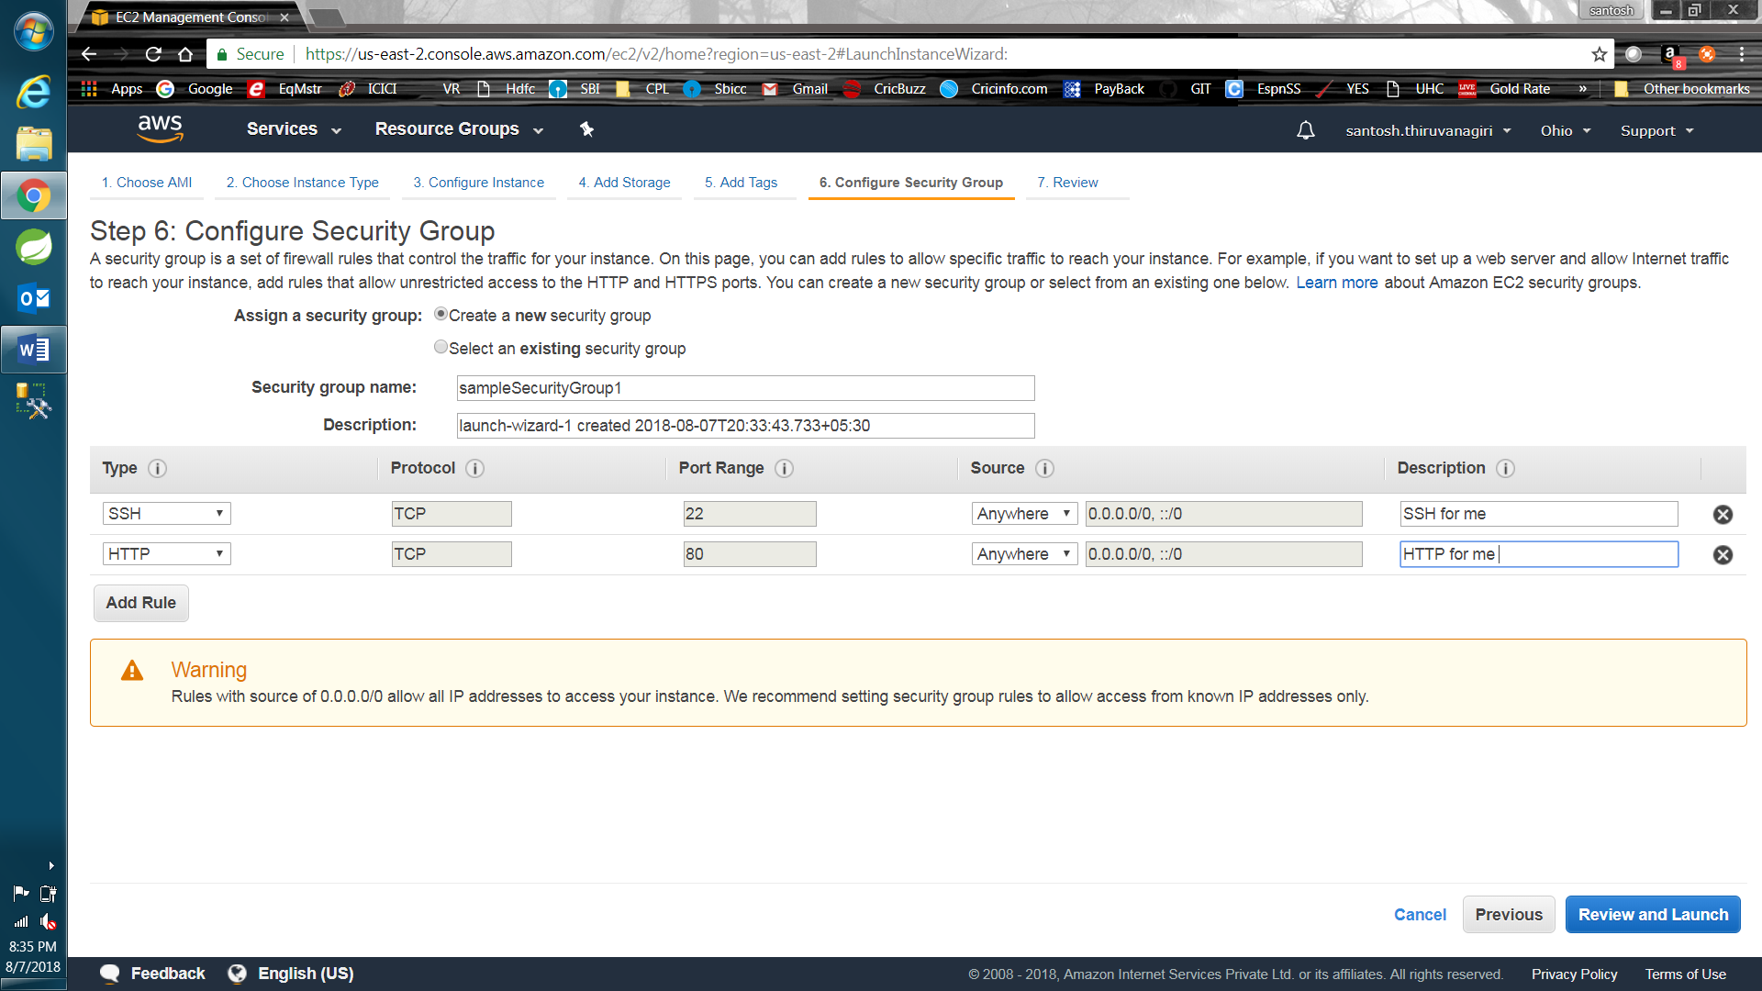

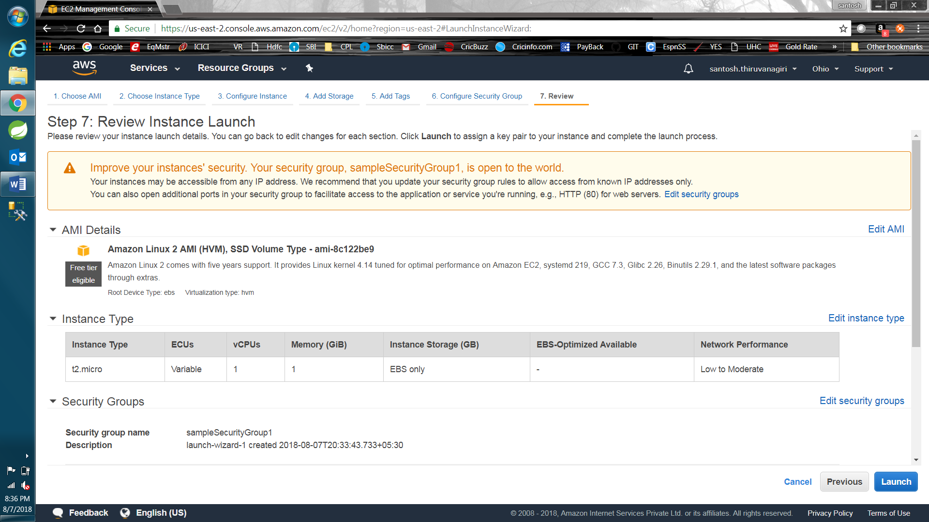

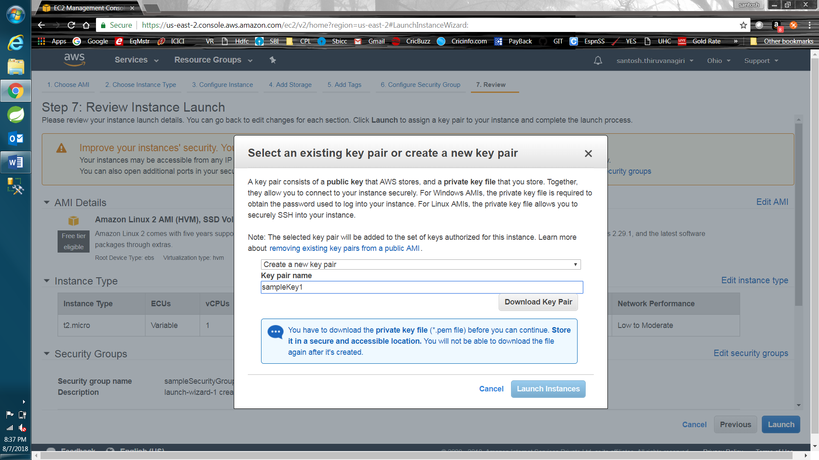

Download key pair to ur system and save it as “.pem” file. Use this key while accessing ec2(while loading in Puttygen).

Then click on Launch instances 🡪 Click on Instance ID

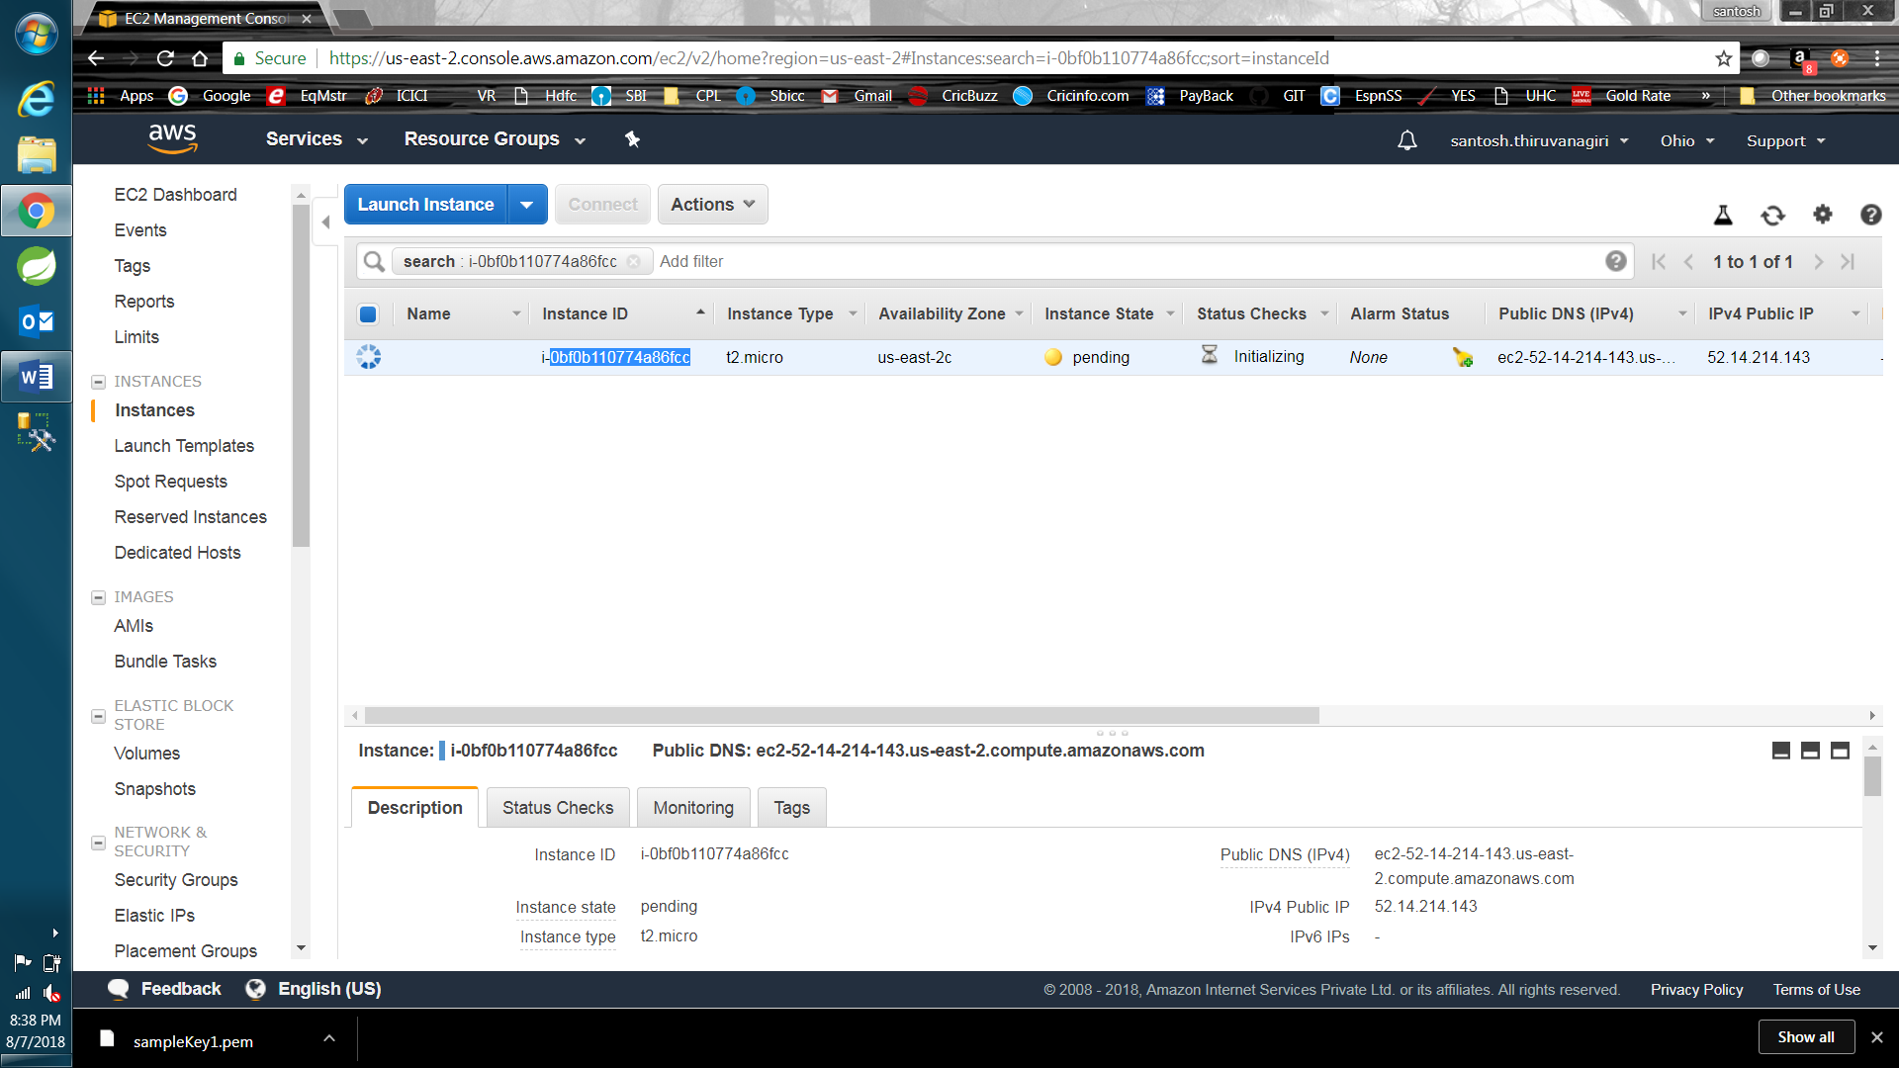

**Download Putty & Puttygen (part of putty download file)**

Open puttygen after installation.

1. Need to load .pem file we downloaded while creating EC2 instance.
2. Need to save primary key
3. Open putty and give this .ppk file which we saved in SSH 🡪 Auth section on left hand side of Putty.

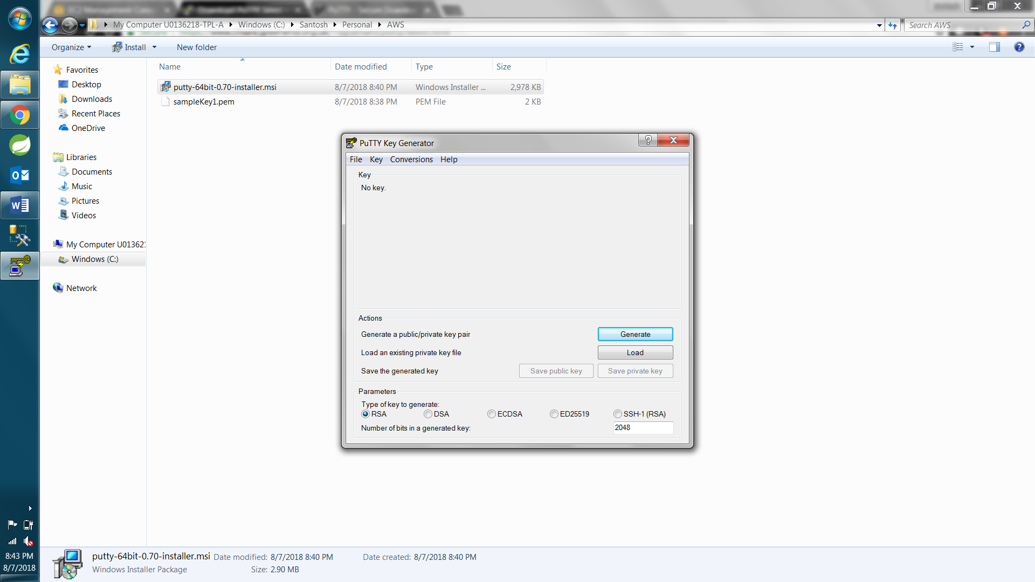

Usage:

Using Puttygen 🡪 Load “.pem” key and ~~then click Generate button to generate Public key~~. Save Private Key with extenstion “.ppk”. Now Open Putty and given [ec2-user@52.14.214.143](mailto:ec2-user@52.14.214.143) & SSH🡪 Auth 🡪 Browse .ppk file that we generated.

.pem 🡪 private key

.ppk 🡪 private key in putty understandable format

Load the “.pem” file we downloaded while creating EC2 instance.

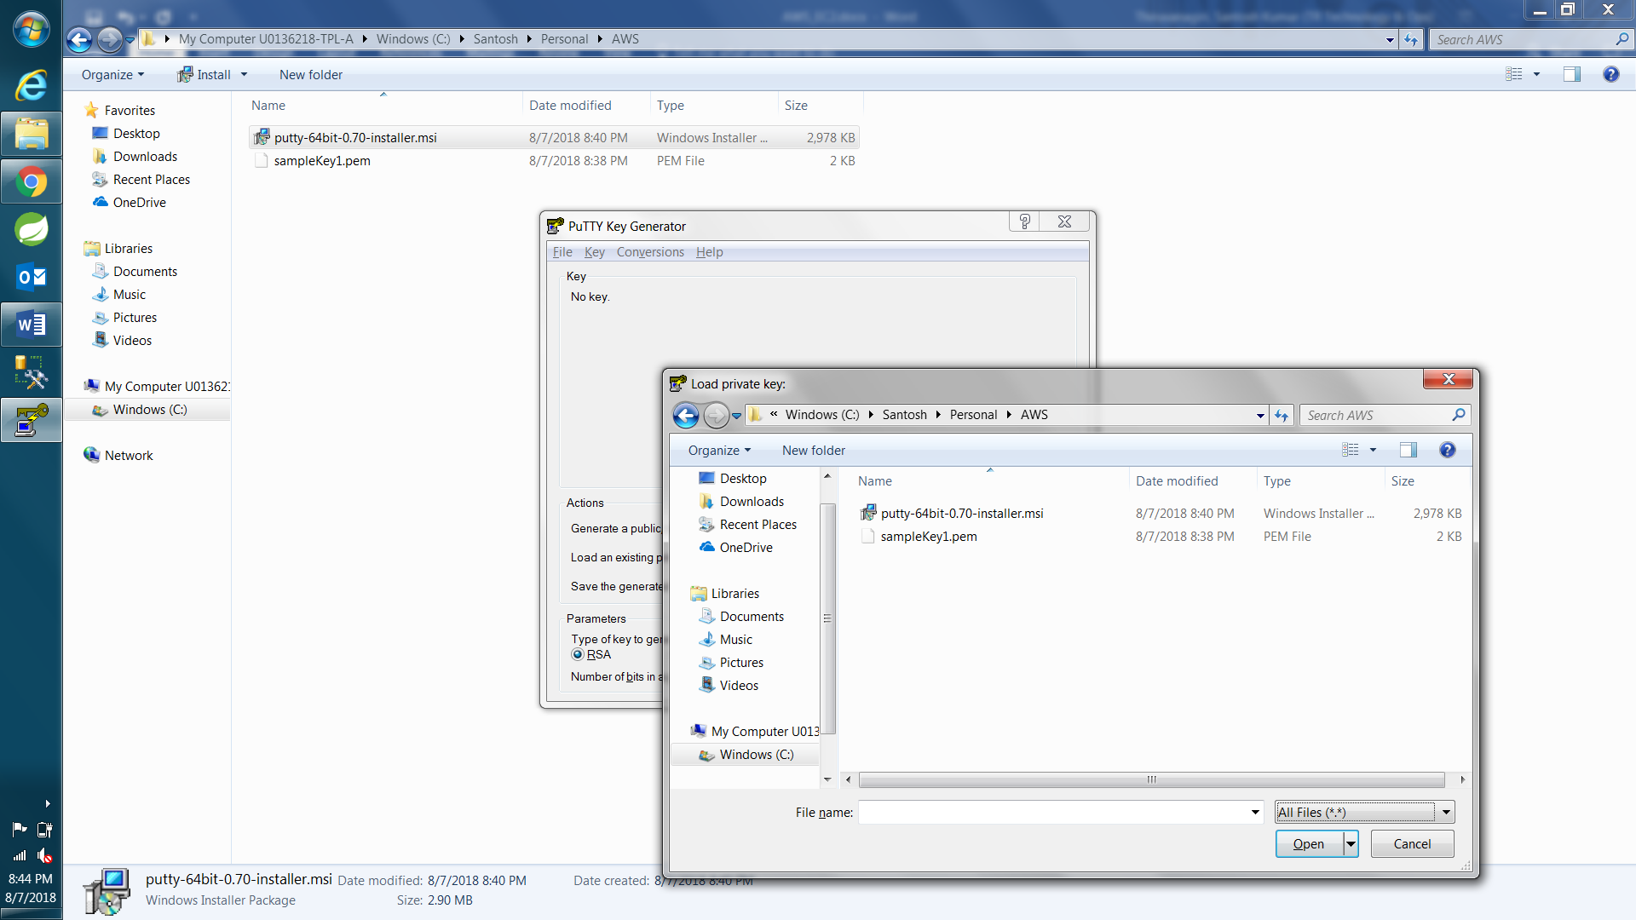

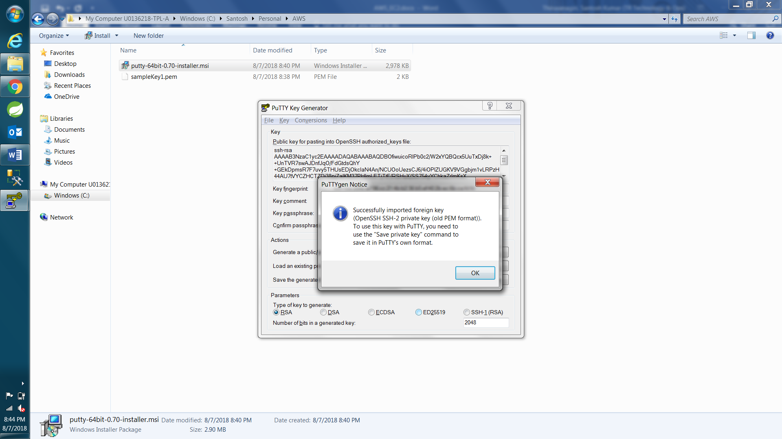

~~Generate button Not needed~~

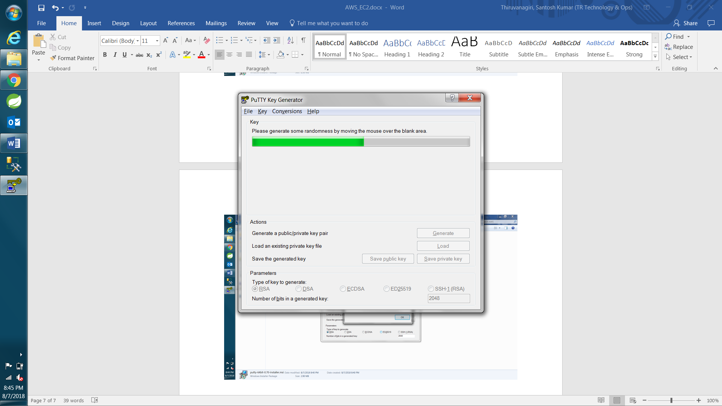

Save Private Key

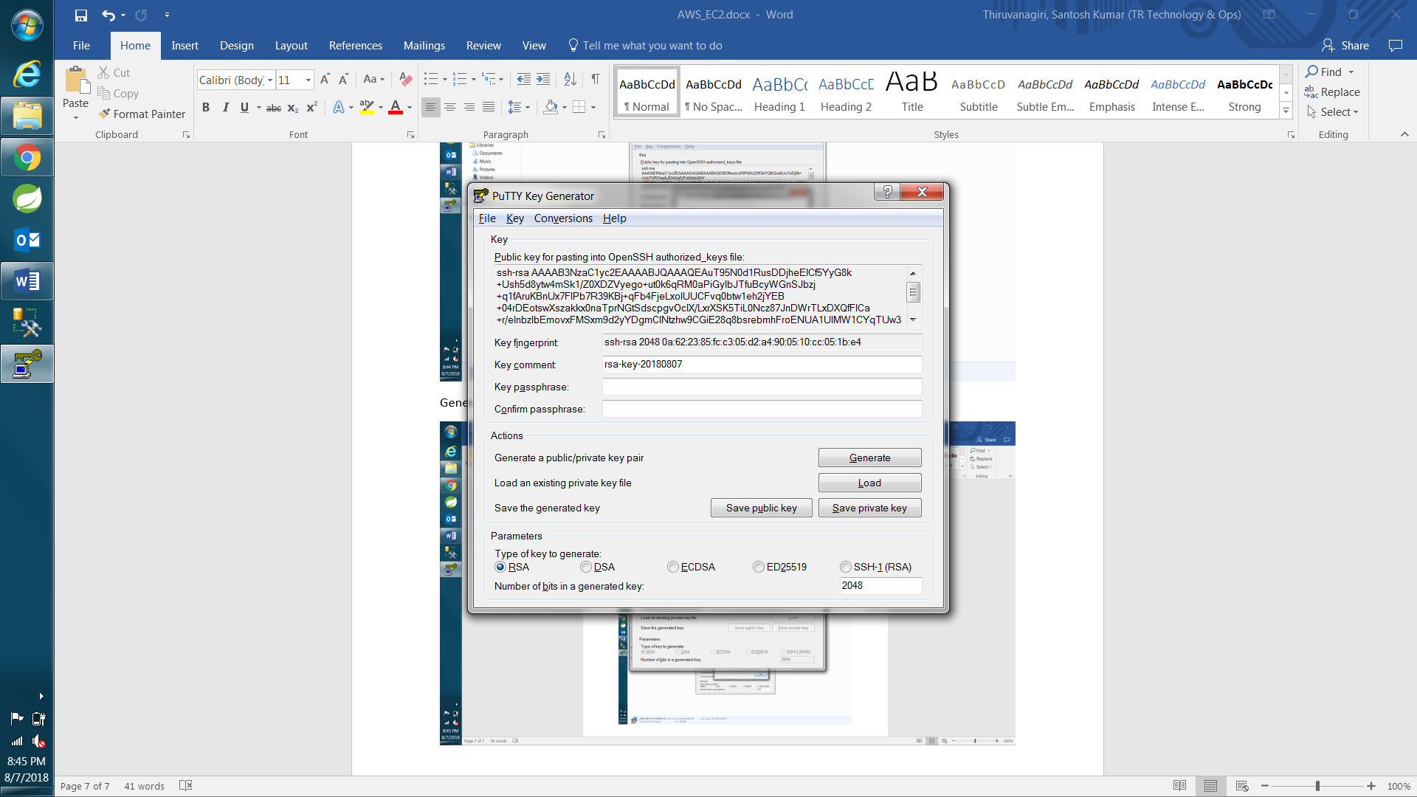

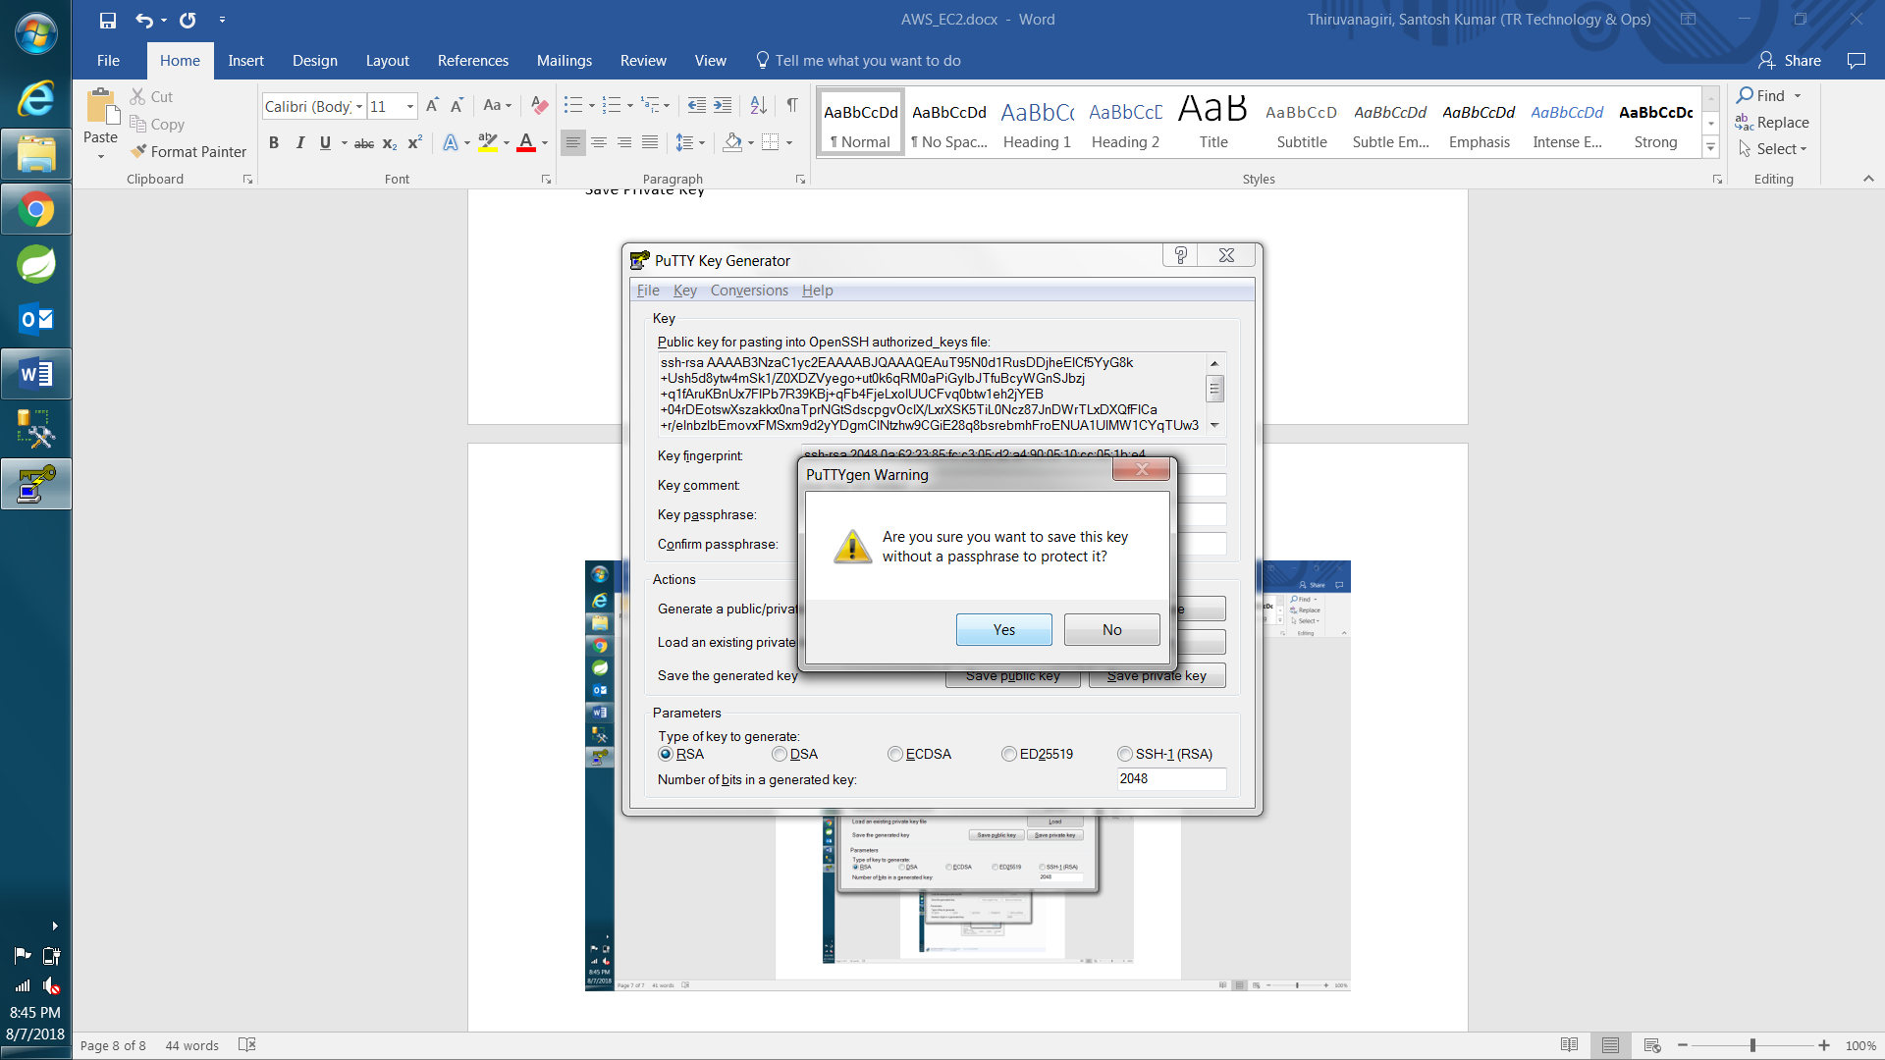

sampleKey1.ppk

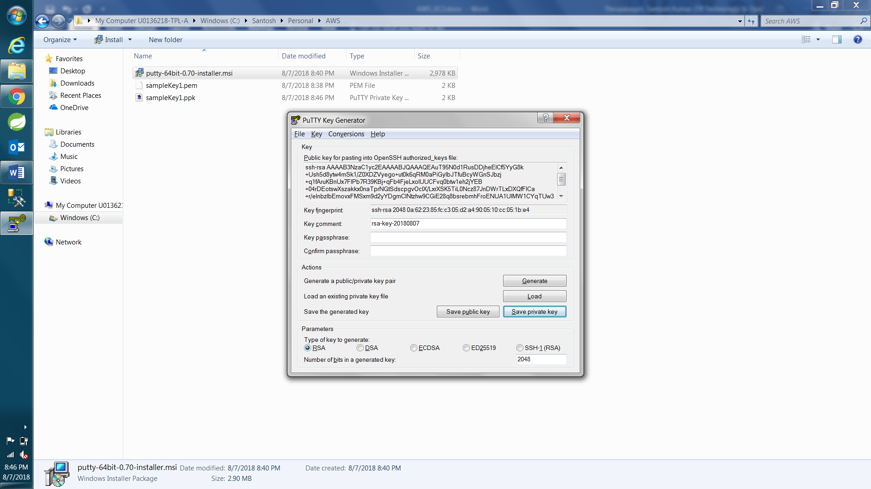

Open Putty and give ec2 instance – [ec2-user@52.14.214.143](mailto:ec2-user@52.14.214.143) as Hostname

Select SSH auth from left hand side options in putty(MUST)

SSH 🡪 select Auth 🡪 Browse the saved private key “.ppk” file

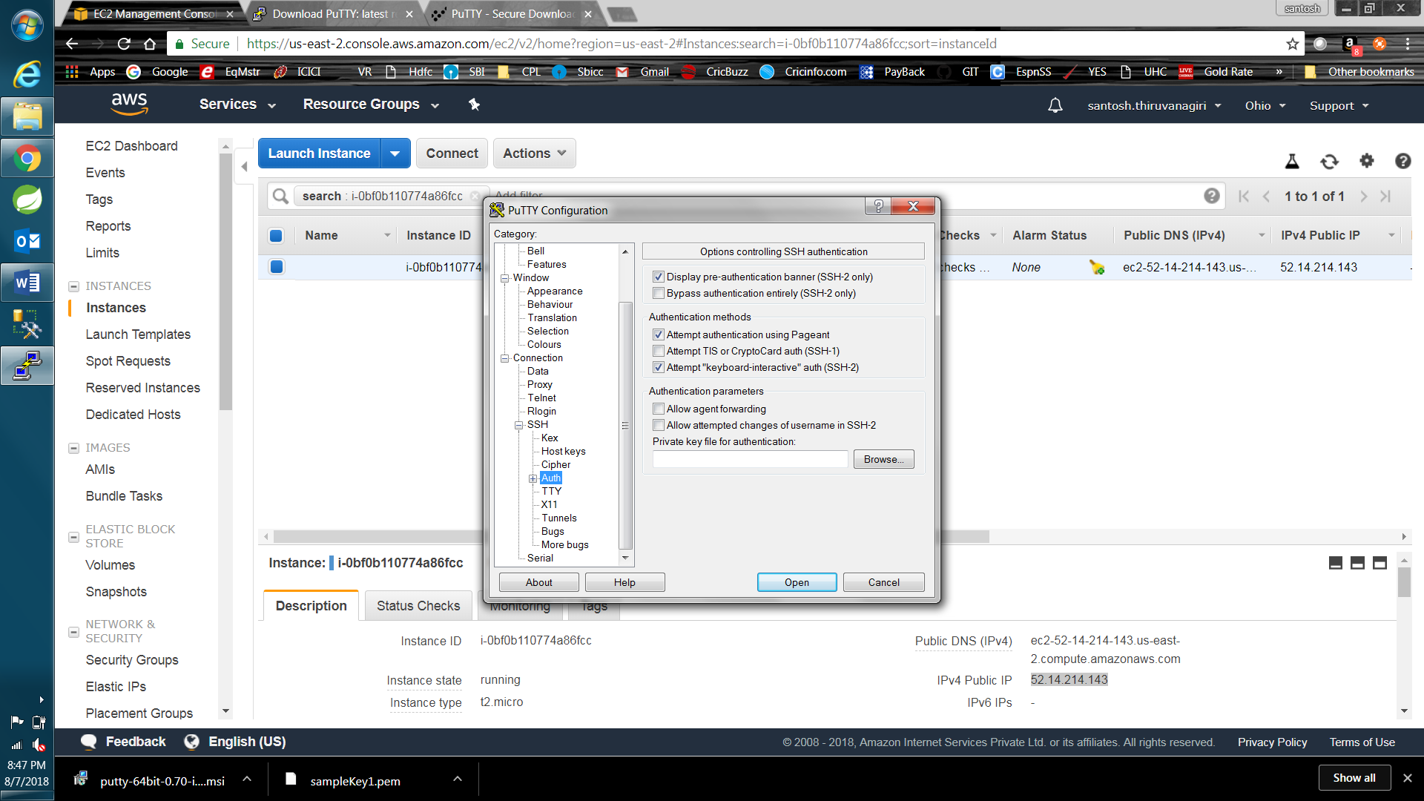

Error: To solve this, we need not click GENERATE button in puttygen after LOAD. Directly Save Private Key after LOAD.

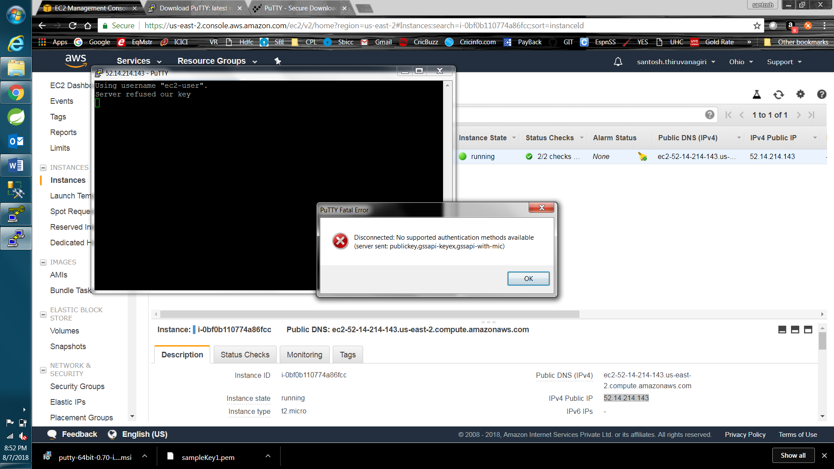

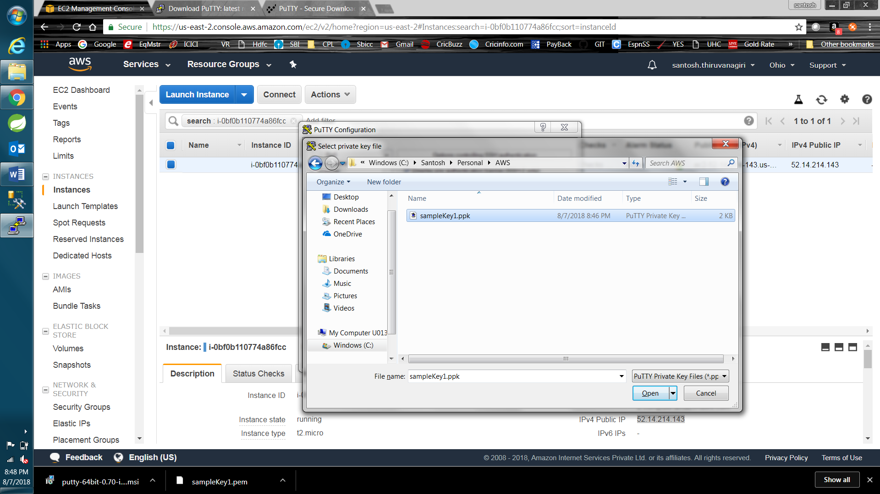

Open

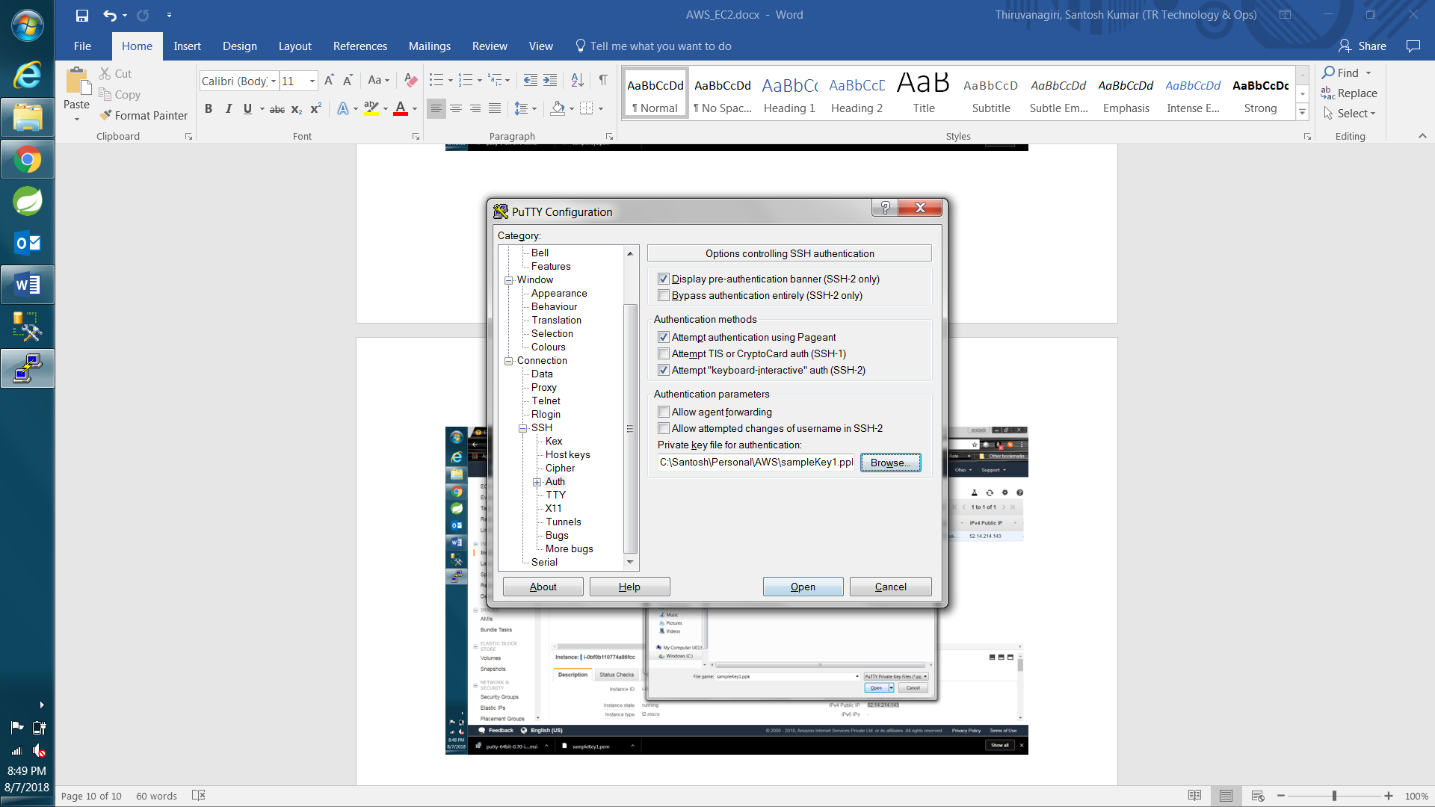

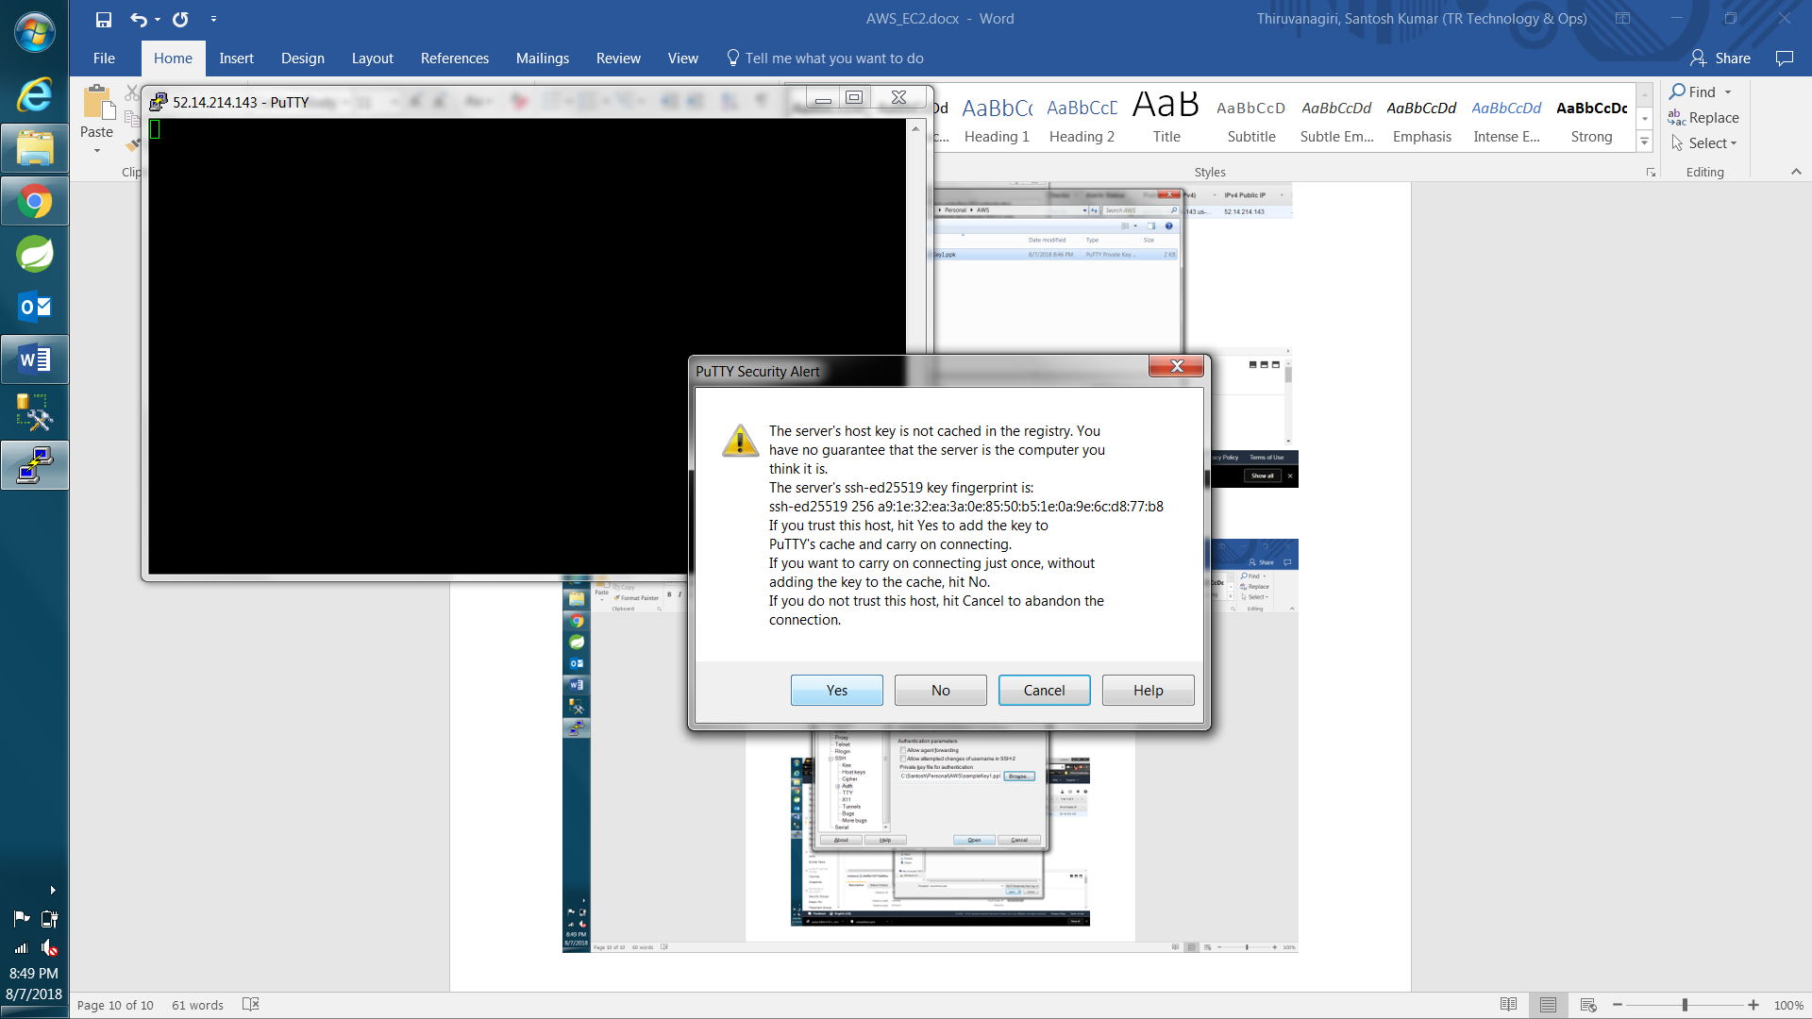

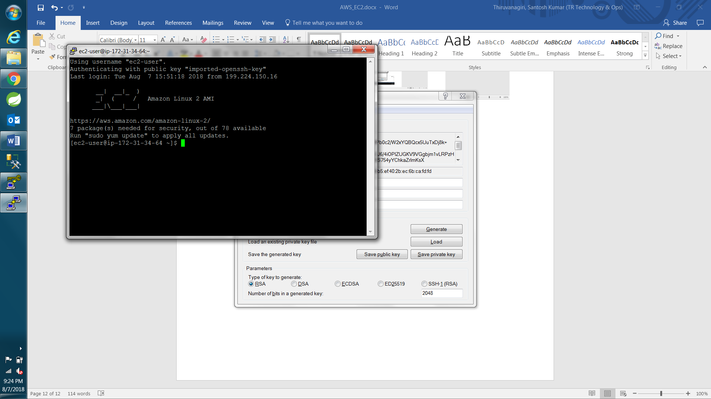

**WinSCP login to EC2 instance via SSH 🡪 Auth**

Open winscp, give public IP address as hostname and username as “ec2-user”.

Then click Advanced and browse the .ppk file which we saved.

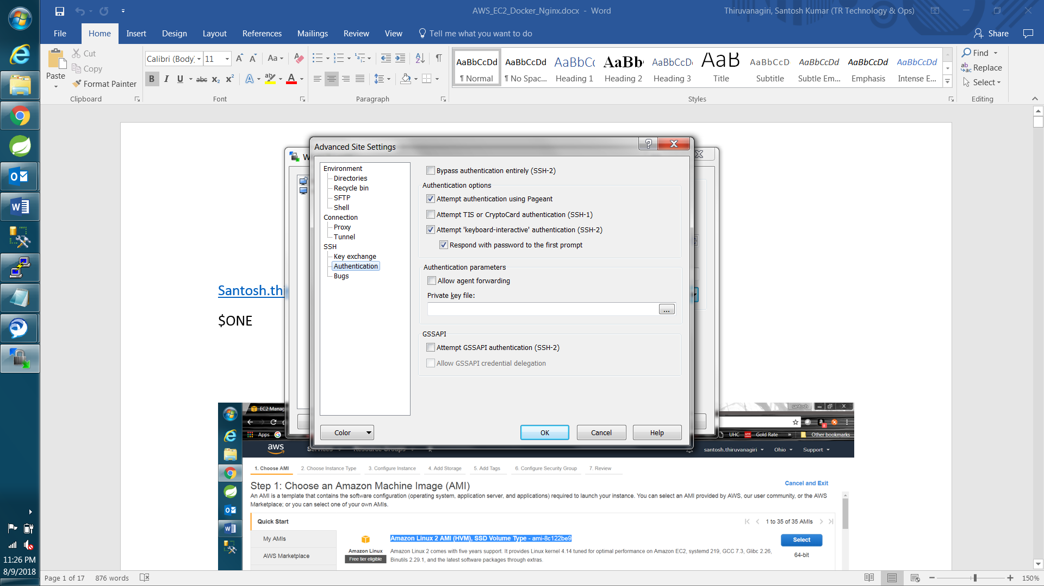

**AWS Billing Dashboard:**

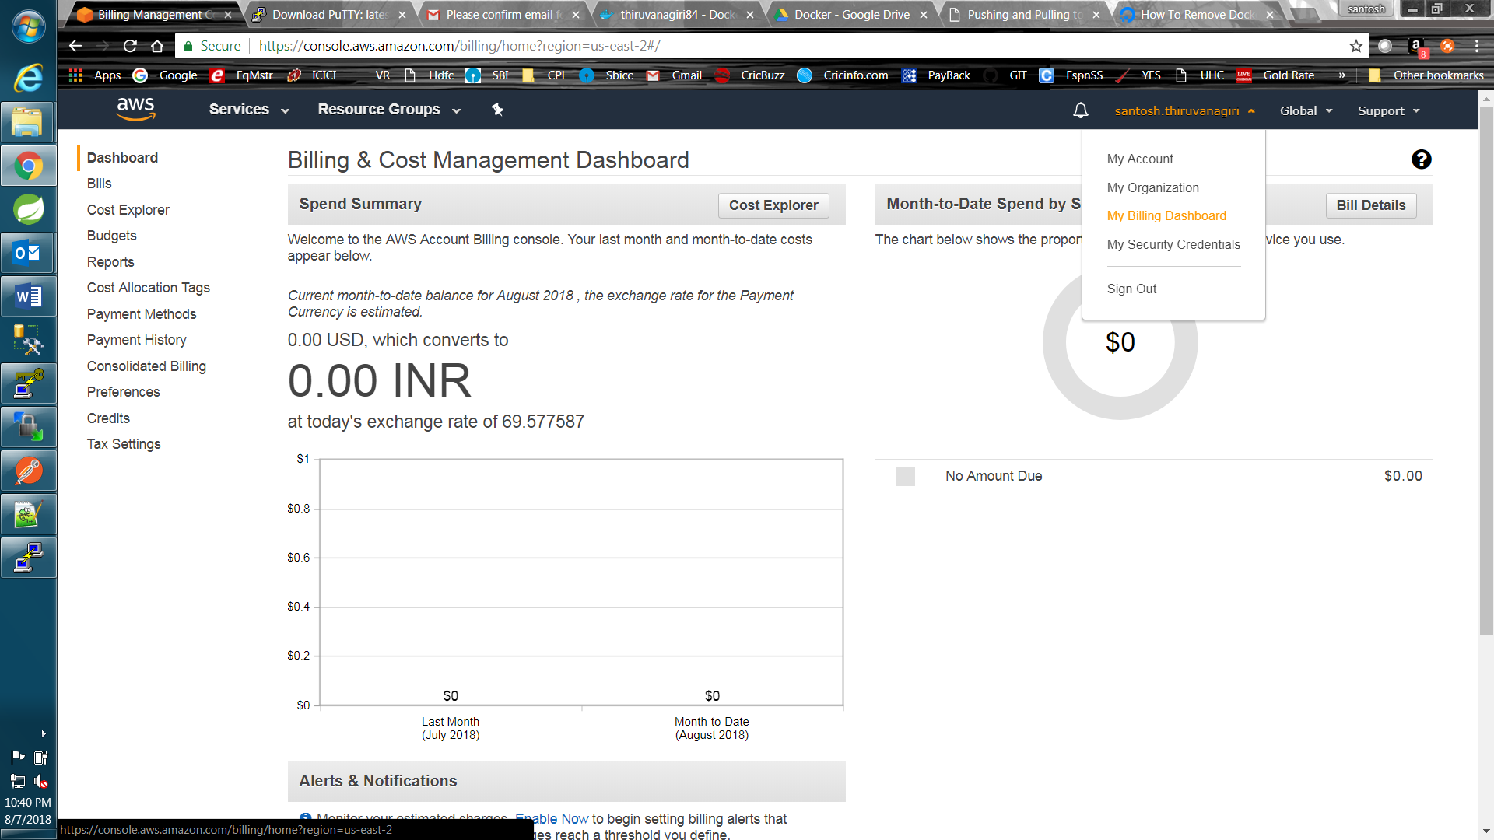

Cost Explorer

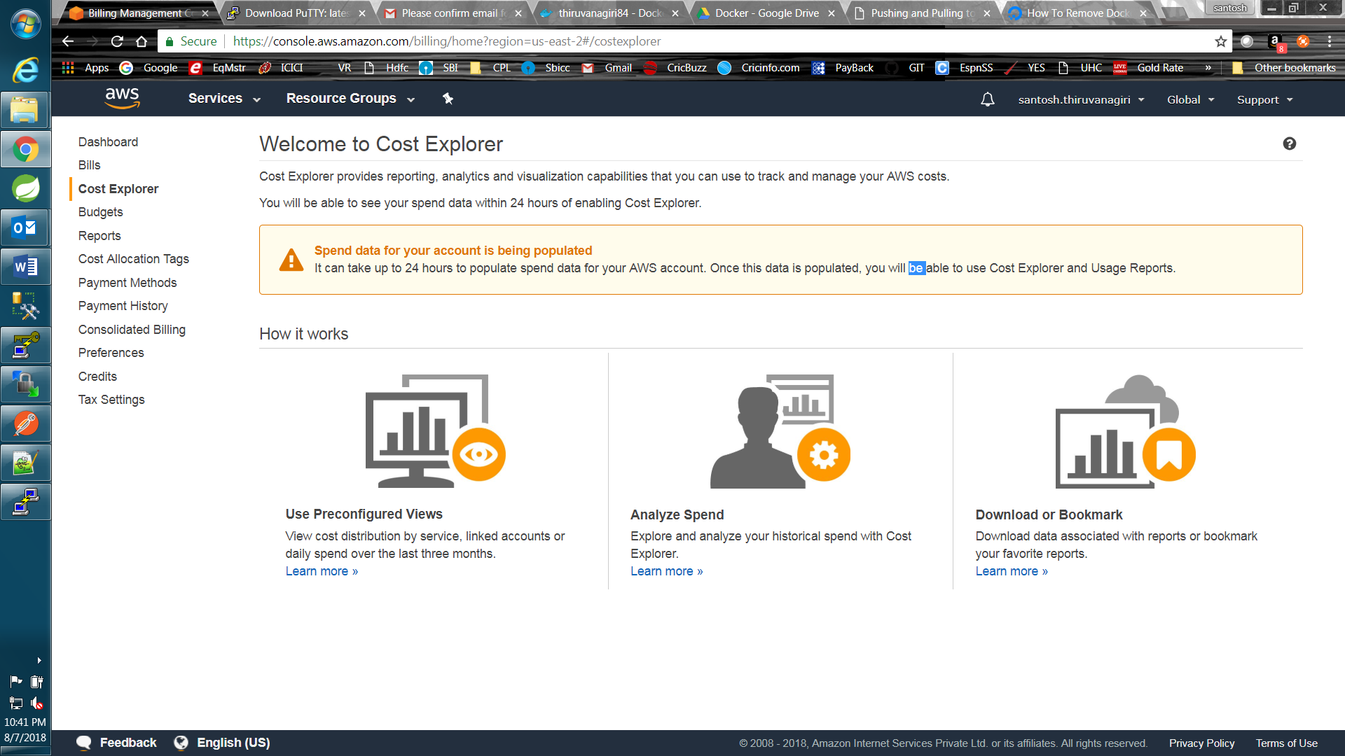

To Stop EC2 instance:

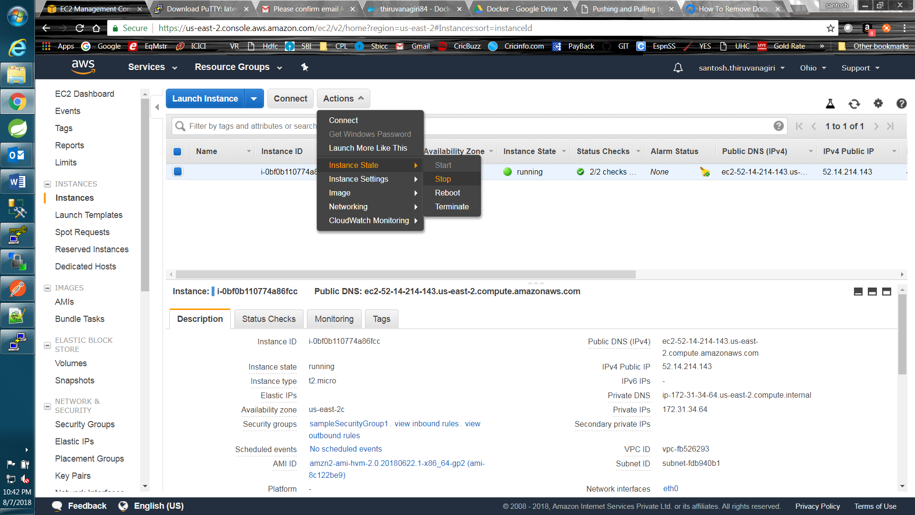

If we Terminate 🡪 entire Ec2 instance will be lost and we need to create new Ec2 instance(Another IP will be generated).

Use the Public IP(for connecting thru Putty and Postman client) mentioned under Description section in above image.

**Docker Installation on AWS:**

<https://docs.aws.amazon.com/AmazonECS/latest/developerguide/docker-basics.html#install_docker>

1. **sudo yum update -y 🡪** Update the installed packages and package cache on your instance.
2. **sudo yum install -y docker**
3. **sudo service docker start**
4. **sudo usermod -a -G docker ec2-user 🡪** Add the ec2-user to the docker group so you can execute Docker commands without using sudo.
5. Logout and login your SSH terminal to pick up the new docker group permissions.
6. docker info 🡪 Verify that the ec2-user can run Docker commands without sudo.

Once docker is installed we can pull the existing images from docker hub as described below:

**Docker push: Used to push docker image to docker hub**

Cmd: docker login

It will ask for docker hub login credentials:

thiruvanagiri84

$ONE

After login, enter following commands to first tag your image and then push it to your docker hub repository.

* docker images
* docker tag mgmt-service-aug thiruvanagiri84/mgmt-service-aug:firsttry

docker tag <image name OR imageID> <dockerhubusername/image name>:<tagname>

* docker images

newly created docker tag will be shown under repository with our created tagname(firsttry)

* docker push thiruvanagiri84/mgmt-service-aug:firsttry

docker push <earlier created docker tag name>:<tagname>

Assumption: Sign in to docker hub and create a repository.

**OR** we can create docker image from a running docker container and then push that image to docker hub.

a. spin a docker container from the docker image.

b. docker ps -a ---- this will list all the running containers

c. docker commit <containerID> <dockerhubusername/anyname>:<tagname>

d. docker images

e. docker push <dockerhubusername/anyname>:<tagname>

**Docker Pull from docker HUB:**

1. docker pull thiruvanagiri84/mgmt-service-aug:firsttry

docker pull <dockerhub username/imagename>:<tagname>

1. docker images
2. our pulled docker image will be shown
3. Run the docker image

docker run -p 8040:8040 -e "SPRING_PROFILES_ACTIVE=qa" -d --name cuasapi-qa thiruvanagiri84/ mgmt-service-aug:firsttry

1. docker ps -a 🡪 this will show list of running containers. Our container will be up after the above command.

**Now try to access via postman:** <http://18.222.45.4:8040/internal/V1/anonymouslogin> (will not connect)

**Here is the problem:**

We have exposed 8040 port of our EC2 instance machine and mapped the requests coming to port 8040 to 8040 mentioned in the application. (8040:8040).

But we haven’t mapped our EC2 running port 80(created during security group stage while Launching EC2 instance) to 8040. This will be done by “nginx” load balancer. We need to modify nginx.conf script for mapping EC2 default port 80(which we exposed to outer world) to 8040.

**Installing NGINX on AWS:**

<https://aws.amazon.com/amazon-linux-2/faqs/#Amazon_Linux_Extras>

<https://github.com/carlosCharz/installtomcataws>

1. sudo amazon-linux-extras install nginx1.12
2. Afterinstalling nginx load balancer, add configuration changes in etc/nginx/nginx.conf and add below line in that file.

To open the file for editing,

1. Go to the directory, cd /etc/nginx
2. use cmd 🡪 sudo nano etc/nginx/nginx.conf (to remove sudo, type cmd “sudo su” <Enter>, this will give root access)
3. Search for server {

listen 80 default_server;

below you will find location/{

}

1. Paste below code at this location.
2. Save the fix by Ctrl+x and then y then <Enter>

***location / {  
  
         proxy_connect_timeout 300;  
  
         proxy_send_timeout 300;  
  
         proxy_read_timeout 300;  
  
         proxy_pass http://localhost:8040;  
  
        }***

1. service nginx start 🡪 This will start load balancer. **V.imp Step**

**Tip:** vi etc/nginx/nginx.conf

Save file after writing 🡪 ESC then :wq

Come out of file without savings 🡪 ESC then :q!

Likewise, we can create many ports while creating EC2 instance and each port should be happing a mapping to our own ports inside EC2 machine. We need to search for Server{ in the nginx.conf script and modify accordingly. Ex below:

<https://github.com/carlosCharz/installtomcataws>

Search for : Add Nginx Domain Binding